Cushing’s Disease
What is Cushing’s disease?
Cushing’s disease is an endocrine disease which occurs as a result of long term exposure to excessive levels of cortisol, a steroid like hormone produced by the adrenal glands. Cortisol is released to help the body cope with times of stress, however if levels remain elevated for long periods of time this can cause debilitating effects on many body systems.
What are the clinical signs?
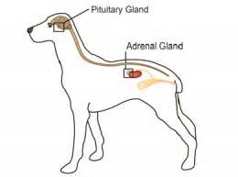
Signs typically come on gradually and therefore may be confused with the normal aging process.
- Drinking excessively
- Urinating excessively
- Increased appetite
- Pot-bellied appearance
- Incontinence (urine leakage)
- Muscle weakness
- Skin/haircoat abnormalities
How is Cushing’s disease diagnosed?
Testing your pet is generally done through urine and/or blood tests. Given many other disorders may falsely elevate cortisol levels, more than one test may be necessary to accurately diagnose your pet with Cushing’s disease. Some of these tests may require your dog to stay at our clinic for the day.
What is the treatment?
The most current treatment recommendation is Trilostane, a capsule, given orally once to twice daily. Trilostane works by decreasing the production of cortisol by the adrenal glands. This drug treats Cushing’s disease but does not cure it, therefore medication must be given for life.
What monitoring is required while on treatment?
Just like in humans, long term medications require careful monitoring. Since the internal organs need to process these medications, it is important to keep a close watch on the body’s organ function. This is done through lab tests and physical exams, which are performed more frequently in the beginning of treatment. Once we determine the medication is at the appropriate dose and no adverse changes are occurring to your dog’s internal organs, monitoring of lab work may only need to be evaluated every 6-12 months.

